Udemy Ethereum course Notes

# Section 1

## 3. Why you should learn blockchain

5 different companies looking for blockchain people

1. Start-ups (Angel list)
2. Corporate tech firms (IBM, Microsoft) (check blocktribe.com)
3. Banks
4. Governments
5. Professional services firm (e.g. The Big 4)

Requirements that they ask for

* Code in various languages (Java, C++)
* Comfortable with Large Data
* Understand Cryptography
* Understanding of the Blockchain

## 4. Ownership…

Ownership is different from Possession

### 5…

## 6..

What web 3.0 refers to:

Connective intelligence

connecting data

concepts application

If you understand google docs you can understand blockchain. In the sense that documents can e modified at the same time by people

1. Install Metamask

Went over what the other networks are. He uses the rapsten test network

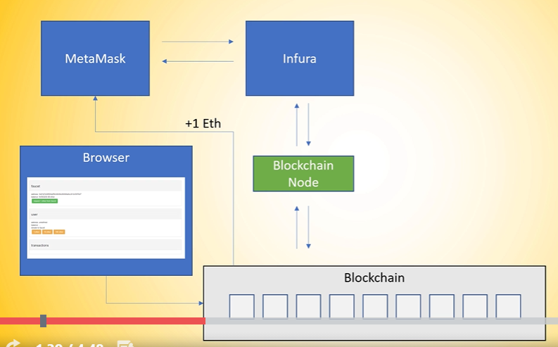

“Now that isn't so much magic. There is an actual service in the background that is called in Führer where a metal mass connects to and in in future is a block chain as a service provider and they internally have block chain nodes running in the background. And as you can see here we are installing metal mask metal mask is actually interacting with Führer. They are hosting parody and go through some notes as far as I know and are opening a RESTful API in order for metal mass to interact with the block chain through a block chain note that they are hosting. Now the next thing that we did is we opened the fourth set like the mathematic falsetto here in the picture or maybe another faucet. It doesn't really matter. You open the browser. You hit some button and the browser through some magic interacted with the block channel and one ether or zero zero zero point zero five Gurley ether appeared you know a metal mask wallet. How is that possible. What happens in the background. There's also it's not rocket science. What is happening in the background the browsers interacting with some sort of backend and the backhand is interacting with the blocking or then sending off a transaction. The important part here is that the key the private key in order to sign this transaction and you're talking about transaction signatures in one of the next lectures the key is stored on the back end of that service that is providing this false set and this has access to the funds they are sending of a transaction from their address which is stored on the block chain ledger to the address that is stored in our mathematic wallet. And now as you can see here the ground truth is the block chain where it mathematic value in Europe by block should note has access to the blocks and data and the browser via the backend via the blocks the note has also access to the same block data. So we have one shared ledger across those two services. Now every time when we made a new transaction we opened the block explorer for the metal mask bug explorer. We were on the Robson test network that was Robson ethos candidate AOL. They are running a block explorer and on the girl it has network. It was Gurley thought if scandal. They all it's the same log explorer. Also no rocket science. They're either scan is interacting and hosting their own block channels and having a copy off the block chain locally on their data center and processing this block chain with all the transactions and showing us the result in the browser window. Now you can see here already. Every time we want to interact with the block chain we need a block to node and the block chain is the single source of truth underlying the data having stored there. Now you can imagine there is a lot more going on than not other nodes are interacting with the block. You know we can actually download our own node now which is going theorem or have a larger basal or parity and they are all doing pretty much the same thing. They are connecting to the block chain and starting to download the blocks locally. And in order for us to avoid this downloading for now we're going to do it later in the course but for now we just want to get started doing something with the block chain we can use services like in future to interact with the block chain by a hosted block channel. All right. What are the key takeaways here. The first thing is you need a block channel to interact with the block chain. This can be hosted node or your own node. In our case it was a hosted node they block chain is the single source of truth in the whole systemwhere we have a shared ledger across all participants which can get access to the same data. And there are infrastructure providers that abstract this running a block chain away from developers from users and make onboarding quite easy. All right. That's it for this lecture. And in the next one we are talking a little bit more about cryptography and transactions.“

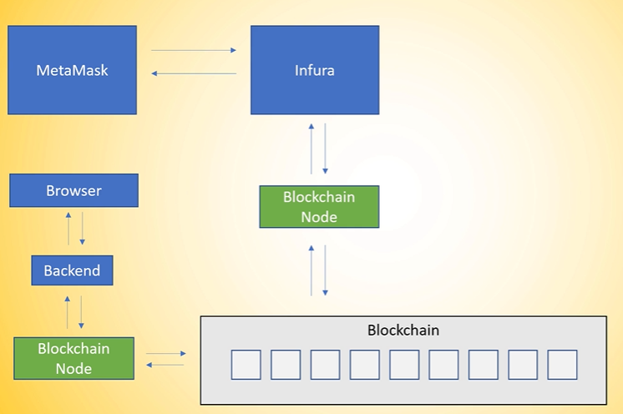

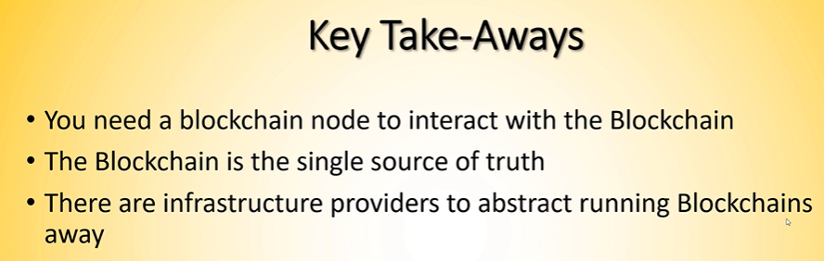

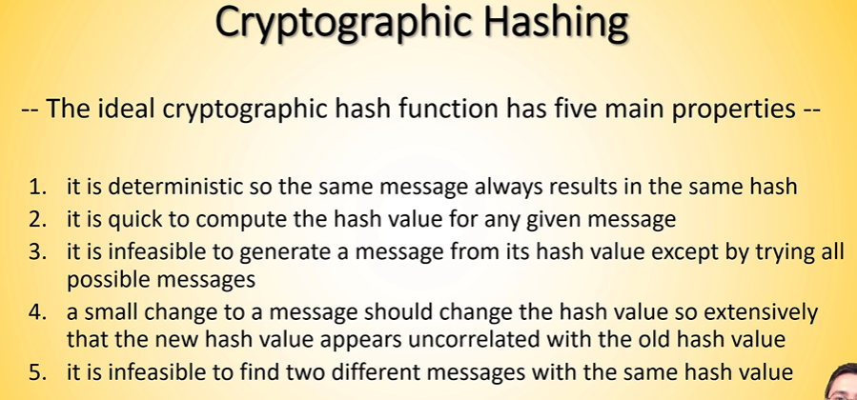

## 13…

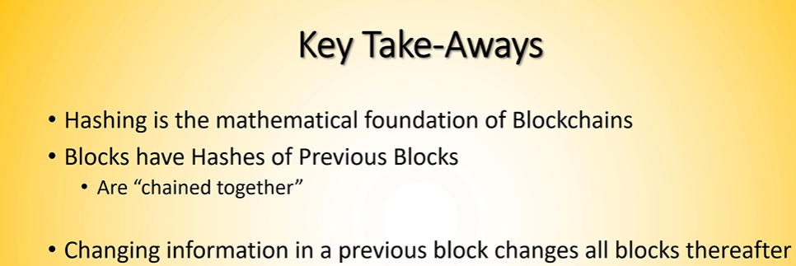

## 14…

COME BACK TO THIS ONE!

## 15 Lab

A couple of ways to program solidity. Any text editor. We will use **remix.ethereu.org**

Other smart contract languages: Vyper, LLL, Solidity

Vyper is less error prone than solidity

When code gets compiled from the language sabove, what gets sent to the blockchain is EVM Bytecode.

Introduce the concept of Turing complete. Solidity is Turing Complete

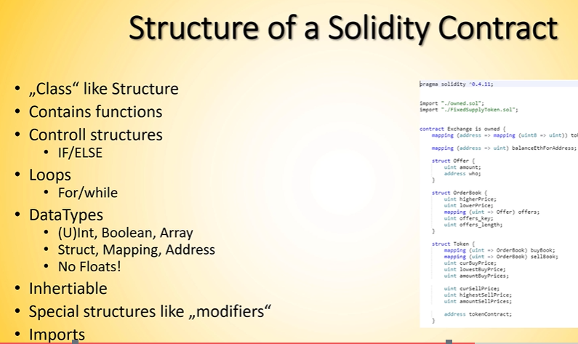

(I am pretty sure the 3rd to last bullet above should say “inheritable”)

Some general structure of a smart contract:

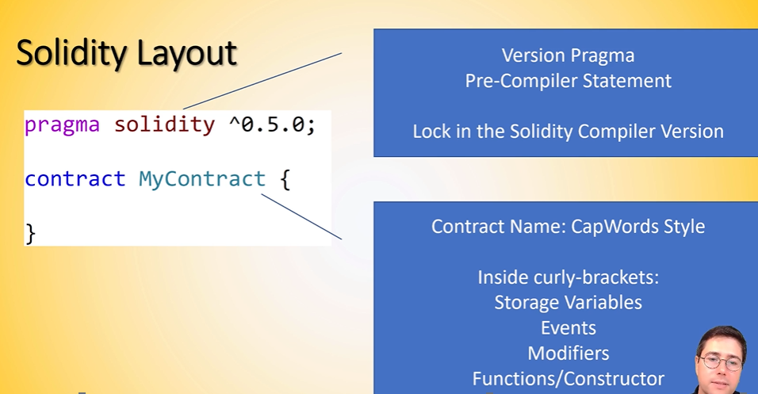

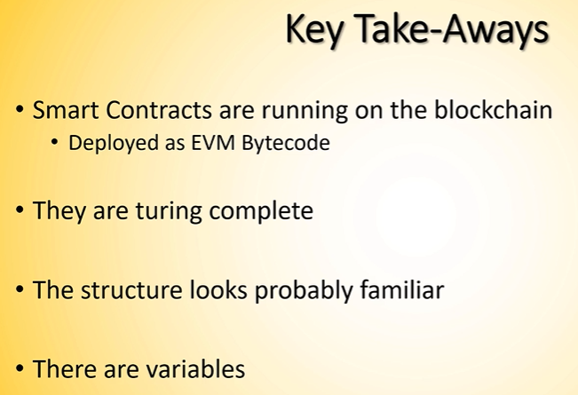

## 18.. lab

## 19..